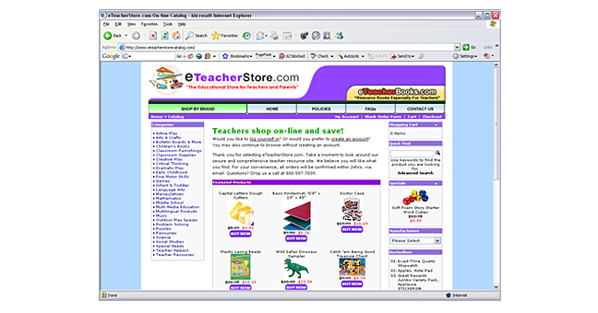
Client: e Teacher Store www.eTeacherStore.com

Business
Mail order and online ecommerce of teaching supplies, educational materials at discount prices.

Project description
e-commerce website catering to the needs of schools, teachers, and parents.

Clients needs
Client believed that if they had an up-scale web presence that he could capture a larger percentage of the target market.

Solution
Design and develop a fresh new website that utilizes an existing database driven e-commerce solution.

Project completed
1999

Updates to project
2002, 2005

Unique features of project
Professional designed look for a website that shares a cookie cutter leased e-commerce solution, setting it apart from competitors who share the leased functionality.

Technologies
HTML, Java Script, Frames,

My Role
Art Director, Designer, HTML Developer

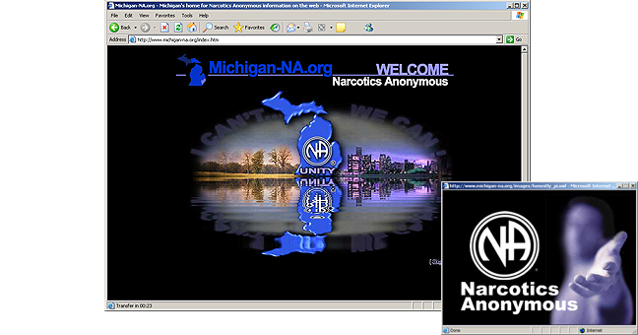
Client: Narcotics Anonymous of Michigan www.Michigan-NA.org

Business
Non-profit 12 step fellowship for recovering drug addicts.

Project description
Statewide Web presence centralizing all Regional and individual Area Service Efforts.

Clients need
A Unified and centralized website housing all Regional and individual Area Service information, events, meeting lists, maps to meetings.

Solution
Established a website committee within regional and area service structures. Implemented common navigation system and developed style guide for consistency.

Completion, updates
2000, Continual weekly updates

Unique features of project
Updating process established which allows new volunteers to become involved and be replaced when no longer involved without negative impact to the web presence.

Technologies
HTML, Java Script, Flash,

My Role
Art Director, Designer, HTML, ASP Developer

Others who worked on project
Volunteer non-designer, non-technical staff of 30
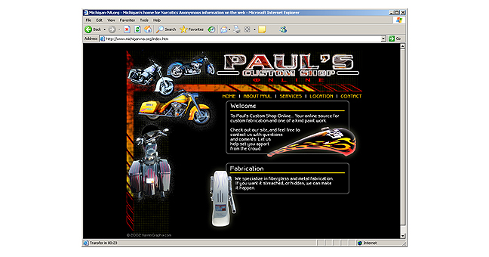
Client: Paul’s Custom Shop www.PaulsCustomShop.com

Business
Custom Auto/Motorcycle painter

Project description
Web presents showcasing the custom paintjobs, artwork & fabricating services of Paul’s Custom Shop.

What client was trying to accomplish
The client did not have a web presence and was optimistic that he could attract business if he could broaden his exposure to his target market.

What was the solution
Designed and developed a brand Identity complete with letterhead, business cards and a website showcasing the capabilities of Paul’s Custom Shop.

When project was completed
2002

Unique features of project
Designed around artwork based on and complementary to photos of custom paint work and fabrication

Technologies
HTML, Java Script,

My Role
Art Director, Designer, Developer

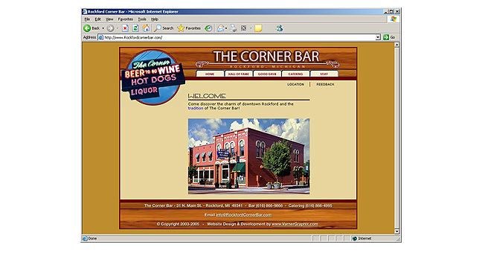
Client: Rockford Corner Bar www.RockfordCornerBar.com

Business
Historic Bar in Downtown Rockford famous for their Hot Dogs

Project description
Design an informational company website that would convey the Historic “Home Town Rockford” feel to existing and potential customers.

Clients need
Client did not have a web presence and was looking to this project to broaden the Rockford corner bar clientele and provide information about the bar’s heritage to new and established customers.

Solution
Establish a website with information about history of the business, services they offer and provide an e-commerce location for Rockford Corner Bar memorabilia.

Project Completion
2003

How many updates
Refresh website design 2005, add new Events section 7/2006

Unique features of project
Outlines “Hot Dog - Hall of Fame” aspect of the restaurant enticing others to take the challenge of beating the long standing Hot Dog eating record and winning a reward.

Technologies
HTML, Java Script, Flash,

My Role
Art Director, Designer, Developer

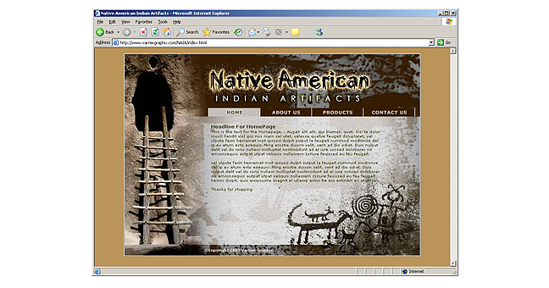
Client: Native American Indian Artifacts www.NativeAmericanIndianArtifacts.com

Business
Client sells rare one-of-a-kind Native American Indian artifacts

Project description
Web presence showcasing unique products for a very small collector market.

Clients need
Client saw several unsuccessful competitors’ websites as lacking in style and believed that if he had an up-scale web presence for the high ticketed collector artifacts he sells, that he could capture a larger percentage of a very small market.

Solution
I Established a design centered on traditional Indian historical artwork and imagery. I developed an e-commerce solution and category structure that is easily updatable by client.

Project completion
2005

Updates
After initial development, the customer can update his own site on an ongoing basis as products rotate in and out of stock.

Unique features of project
Rotating background graphics that keep the site looking fresh.

Technologies
HTML, Java Script

My Role
Art Director, Designer, HTML, ASP Developer
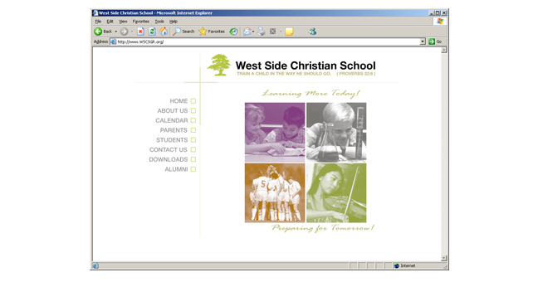
Client: West Side Christian School www.WSCSGR.org

Business
Private Christian K-8 Middle School

Project description
Deign and develop clean web presence outlining the school’s philosophy and core competencies.

Clients need
Client wanted to introduce potential families to our quality Christ-centered education, and to communicate to current families about school news and activities

Solution
Established a very clean functional design centered on Christian values.

Project completion
2005

Updates
After initial development, the customer can update calendar of events in a web based application.

Unique features of project
rollover-image main page design, showcasing ENCOURAGE, CREATE, MOTIVATE, CHALLENGE concepts for building a strong Christian foundation in children.

Technologies
HTML, Java Script

My Role
Art Director, Designer, HTML, ASP Developer

